Linking @Illinois Account to Google Apps

This manual contains information about how to link your @ Illinois email account to Google Apps. By doing this, you will have the ability to access Google Drive and use online tools like Google Docs, to collaborate with classmates or store assignments online.

Enable the use of Google Apps in the Illinois Cloud Dashboard:

On the Cloud Dashboard<https://cloud-dashboard.illinois.edu/>

1. Log in with your NetID and campus password.
2. Click the "On" button for Google Apps @ Illinois, below "Account Status."

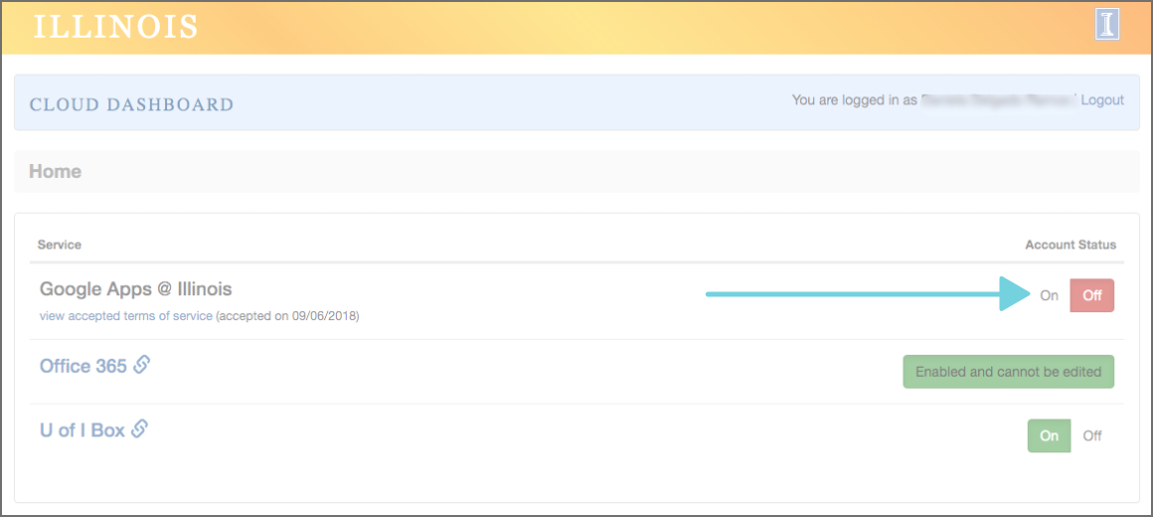

1. Review the Terms of Service and press the "Accept" button. After a moment, your account status will display as "On."

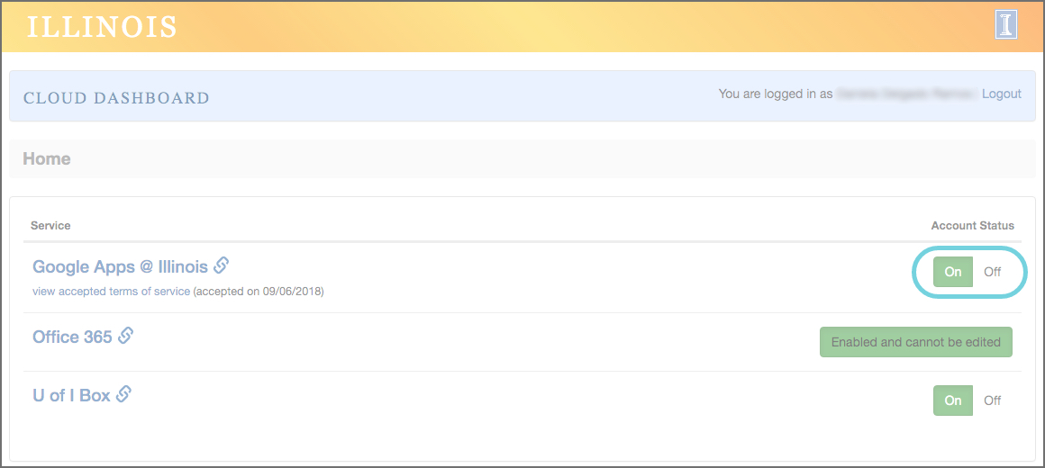

Sign in to your new Google Apps account:

by clicking on the "Google Apps @ Illinois" Cloud Dashboard link or by visiting [**http://docs.g.illinois.edu**](http://docs.g.illinois.edu/).

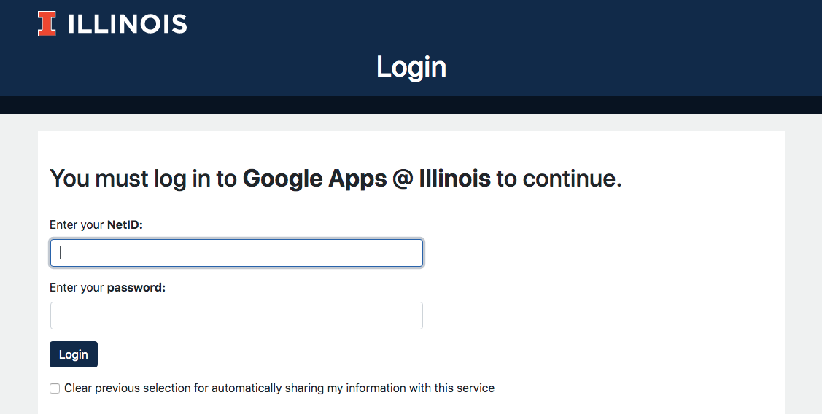

Upon the first login, you will need to accept the Google terms of use by clicking "I accept. Continue to my account."

Enjoy Google Apps @ Illinois!

These steps are enough to access a Google drive space using your @Illinois account. We will need this to work on class projects.

For more information about Google applications manage by your university account, please refer to: <https://techservices.illinois.edu/services/google-apps-illinois/details>

Google Drive app for your desktop: <https://www.google.com/drive/download/>